 | 10.1.9 Editors - Compositor Editor - Header - Add Menu - Filter
Table of content
Detailed table of content 1
Add menu - Filter 4
Anti-Aliasing 4
Convolve 4
Denoise 5
Despeckle 6
Dilate/Erode 7
Inpaint 8
Filter 8
Glare 9

Detailed table of content

Detailed table of content
Detailed table of content 1
Add menu - Filter 4
Anti-Aliasing 4
Inputs 4
Image 4
Threshold 4
Contrast Limit 4
Corner Rounding 4
Outputs 4
Image 4
Convolve 4
Inputs 5
Image 5
Kernel Data Type 5
Kernel 5
Normalize Kernel 5
Outputs 5
Image 5
Denoise 5
Inputs 5
Image 5
Albedo 5
Normal 5
HDR 5
Prefilter 6
None 6
Fast 6
Accurate 6
Quality 6
Follow Scene 6
High 6
Balanced 6
Fast 6
Outputs 6
Image 6
Despeckle 6
Inputs 7
Image 7
Factor 7
Color Threshold 7
Neighbor Threshold 7
Outputs 7
Image 7
Dilate/Erode 7
Inputs 7
Mask 7
Size 7
Type 7
Outputs 7
Mask 7
Inpaint 8
Inputs 8
Image 8
Size 8
Outputs 8
Image 8
Filter 8
Inputs 8
Image 8
Factor 8
Type 8
Soften 8
Box Sharpen 8
Diamond Sharpen 9
Laplace 9
Sobel 9
Prewitt 9
Kirsch 9
Shadow 9
Outputs 9
Image 9
Glare 9
Type 9
Bloom 9
Ghosts 9
Streaks 9
Fog Glow 10
Simple Star 10
Sun Beams 10
Kernel 10
Quality 10
Inputs 10
Image 10
Highlights subpanel 10
Threshold 10
Smooth 10
Clamp 10
Maximum Value 10
Adjust subpanel 10
Strength 10
Saturation 10
Tint 11
Glare subpanel with glare type Bloom 11
Size 11
Glare subpanel with glare type Ghosts 11
Size 11
Iterations 11
Color Modulation 11
Glare subpanel with glare type Streaks 11
Streaks 11
Streak Angle 11
Iterations 11
Fade 11
Color Modulation 11
Glare subpanel with glare type Fog Glow 12
Size 12
Glare subpanel with glare type Simple Star 12
Iterations 12
Fade 12
Diagonal 12
Glare subpanel with glare type Sunbeams 12
Size 12
Sun position 12
Jitter 12
Glare subpanel with glare type Kernel 12
Kernel Data Type 12
Kernel 12
Outputs 13
Image 13
Glare 13
Highlights 13

Add menu - Filter

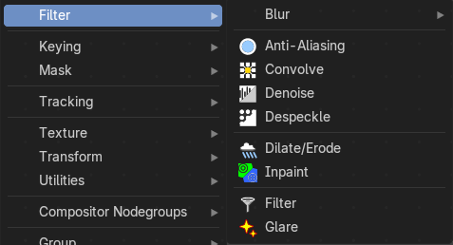
The Filter add menu contains multiple filters you can use on image data, including blurs and other lens effects.

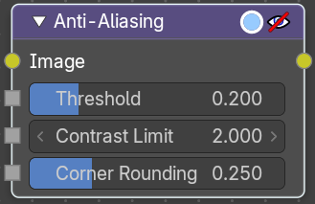
Anti-Aliasing
Adds antialiasing to edges in an image.

Inputs

Image
Standard image input.

Threshold
Threshold to detect edges.

Contrast Limit
How much to eliminate suspicious edges to avoid artifacts.

Corner Rounding
How much sharp corners will be rounded.

Outputs

Image
Standard image output.

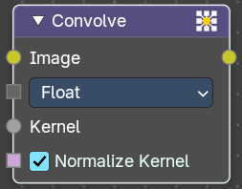
Convolve
Applies a custom convolution kernel to an image, enabling advanced filtering effects like blurring, sharpening, edge detection, embossing, and more. This node gives artists direct control over pixel-level transformations.

Inputs

Image
The source image to be processed. Accepts any RGBA input.

Kernel Data Type
Which data type input to use.

Kernel
A matrix of values that defines the convolution operation. Can be manually defined or procedurally generated. Operates per-channel (R, G, B, A) unless separated beforehand.

Normalize Kernel
When enabled, the kernel values are normalized to prevent brightness shifts.

Outputs

Image
The result of the convolution operation as an image.

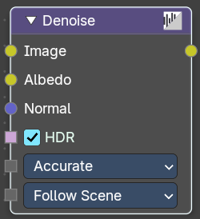
Denoise
The Denoise node is used to denoise renders from Cycles and other ray tracing renderers. This helps to significantly reduce render time by rendering with fewer samples.
It is uses Open Image Denoise, which transforms noisy images into clean images with machine learning.

Inputs

Image
Noise image input.

Albedo
Optional Albedo render pass to better preserve detail. For Cycles, it is recommended to use the Denoising Albedo render pass, which is available when enabling the Denoising Data passes.

Normal
Optional normal render pass to better preserve detail. For Cycles, it is recommended to use the Denoising Normal render pass, which is available when enabling the Denoising Data passes.

HDR
Preserve colors outside the 0 to 1 range.

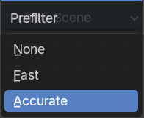
Prefilter
Allows users to apply a prefiltering step before denoising, which can improve the denoising result.

None
No prefiltering applied.

Fast
Applies a quick prefiltering step to improve denoising with minimal processing time.

Accurate
Applies a detailed prefiltering step for the best denoising result, but takes more processing time.

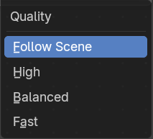
Quality
Defines the quality level of the denoising process:

Follow Scene
Uses the quality set in the scene settings, allowing quick switching between different quality modes for all nodes.

High
Highest quality, but longest processing time.

Balanced
Slightly lower quality, but halves processing time compared to High.

Fast
Further reduced quality for a small increase in speed over Balanced.

Outputs

Image
Denoised image output.

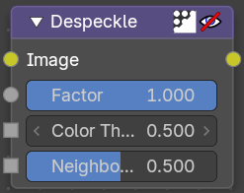
Despeckle
The Despeckle node is used to smooth areas of an image in which noise is noticeable, while leaving complex areas untouched.
This works by the standard deviation of each pixel and its neighbors is calculated to determine if the area is one of high complexity or low complexity. If the complexity is lower than the threshold then the area is smoothed using a simple mean filter.

Inputs

Image
Standard image input.

Factor
Controls the amount the filter effects the image.

Color Threshold
The threshold to control high/low complexity.

Neighbor Threshold
The threshold to control the number of pixels that must match.

Outputs

Image
Standard image output.

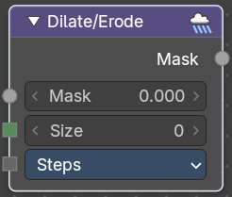
Dilate/Erode
The Dilate/Erode node provides a morphology (mathematical shape analysis) filter.

Inputs

Mask
Single color channel (or a black-and-white image) input.

Size
The filter radius. A positive value of Distance dilates (expands) the influence of a pixel on its surrounding pixels. A negative value erodes (shrinks) its influence.

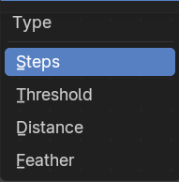
Type
There are four different dilate / erode modes. Step, Threshold, Distance and Feather.

Outputs

Mask
The filtered mask output.

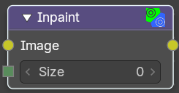
Inpaint
The Inpaint node is used to extend borders of an image into transparent or masked regions. This can be useful to solve problems like “wire removal” and holes created during chroma keying.

Inputs

Image
Standard image input.

Size
The size of the inpaint in pixels.

Outputs

Image
Standard image output.

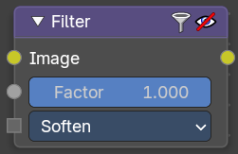
Filter
The Filter node implements various common image enhancement filters.

Inputs

Image
Standard image input.

Factor
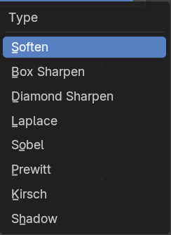
Controls the amount of influence the node exerts on the output image.

Type
The available filter types. Soften, Laplace, Sobel, Prewitt and Kirsch all perform edge detection (in slightly different ways) based on vector calculus and set theory equations.

Soften
Slightly blurs the image.

Box Sharpen
Increases the contrast, especially at edges.

Diamond Sharpen
A moderate sharpening filter

Laplace
Softens around edges.

Sobel
Creates a negative image that highlights edges.

Prewitt
Tries to do Sobel one better.

Kirsch
Giving a better blending than Sobel or Prewitt, when approaching an edge.

Shadow
Performs a relief, emboss effect, darkening outside edges.

Outputs

Image
Standard image output.

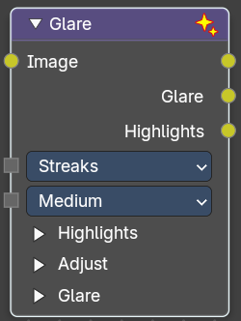
Glare
The Glare node is used to add bloom, lens flares, fog, glows around exposed parts of an image and much more.

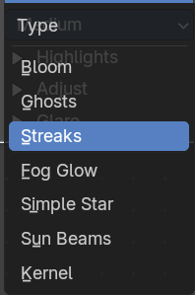
Type
The glare type

Bloom
Creates a bloom effect.

Ghosts
Creates a haze over the image.

Streaks
Creates bright streaks used to simulate lens flares.

Fog Glow
Looks similar to Ghost. However, it is much smaller in size and gives more of an atmospheric haze or “glow” around the image.

Simple Star
Works similar to Streaks but gives a simpler shape looking like a star.

Sun Beams
Creates sun beams.

Kernel
A custom kernel convolution mode. It allows you for example to generate the glare aura of a candle flame.

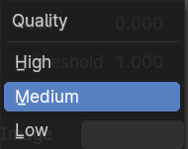
Quality
If not set to something other the High, then the glare effect will only be applied to a low resolution copy of the image. This can be helpful to save render times while only doing preview renders.

Inputs

Image
Standard image input.

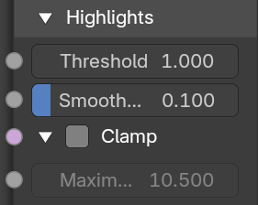
Highlights subpanel

Threshold
Pixels brighter than this value will be affected by the glare filter.

Smooth
The smoothness of the extracted highlight.

Clamp
Clamp the values between 0 and a maximum value.

Maximum Value
The maximum clamp value.

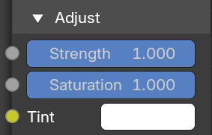
Adjust subpanel

Strength
Soft range of [0, 1], can be boosted beyond 1. Serves the same function as a Mix option but offers better control.

Saturation
Adjusts the intensity of the colors in the glare effect. A higher value results in more vivid colors, while a lower value will desaturate the colors, making them appear more muted.

Tint
Applies a color tint to the glare effect. This allows you to add a specific hue to the glare, giving you creative control over the color balance and overall mood of the effect.

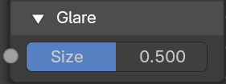
Glare subpanel with glare type Bloom

Size
Scale of the glow relative to the size of the original bright pixels.

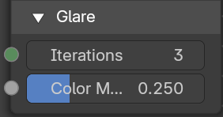
Glare subpanel with glare type Ghosts

Size
Scale of the glow relative to the size of the original bright pixels.

Iterations
The number of times to run through the filter algorithm. Higher values will give more accurate results but will take longer to compute. Note that, this is not available for Fog Glow as it does not use an iterative-based algorithm.

Color Modulation
Used for Streaks and Ghosts to create a special dispersion effect.
Johannes Itten describes this effect, Color Modulation, as subtle variations in tones and chroma.

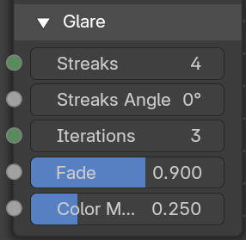
Glare subpanel with glare type Streaks

Streaks
Creates bright streaks used to simulate lens flares.

Streak Angle
The angle of the streaks.

Iterations
The number of times to run through the filter algorithm. Higher values will give more accurate results but will take longer to compute. Note that, this is not available for Fog Glow as it does not use an iterative-based algorithm.

Fade
Controls the gradual reduction of the streaks effect's intensity. A higher fade value means the effect will dissipate more smoothly and subtly over a larger area, whereas a lower fade value will keep the glare more concentrated and abrupt.

Color Modulation
Used for Streaks and Ghosts to create a special dispersion effect.
Johannes Itten describes this effect, Color Modulation, as subtle variations in tones and chroma.

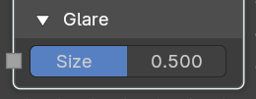
Glare subpanel with glare type Fog Glow

Size
The size of the glare relative ot the image

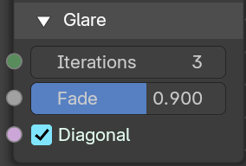
Glare subpanel with glare type Simple Star

Iterations
The number of times to run through the filter algorithm. Higher values will give more accurate results but will take longer to compute. Note that, this is not available for Fog Glow as it does not use an iterative-based algorithm..

Fade
Controls the gradual reduction of the streaks effect's intensity. A higher fade value means the effect will dissipate more smoothly and subtly over a larger area, whereas a lower fade value will keep the glare more concentrated and abrupt.

Diagonal
Align the star diagonally.

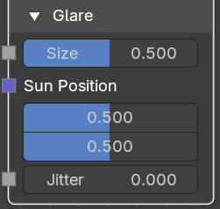
Glare subpanel with glare type Sunbeams

Size
Scale of the glow relative to the size of the original bright pixels.

Sun position
The position of the source of the rays in normalized coordinates. 0 means lower left corner. 1 means upper right corner.

Jitter
The amount of jitter when computing rays.

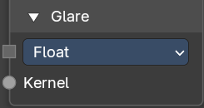
Glare subpanel with glare type Kernel

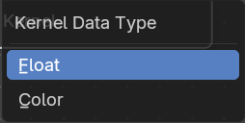
Kernel Data Type
What data to compute for the kernel. Float or color.

Kernel
The kernel input.

Outputs

Image
Output with the generated glare result.

Glare
The generated glare only.

Highlights
The highlights from the generated glare.

